**Human Activity Recognition using Embedded Smartphone Sensors**

Kamlesh Bhati, Ketan Bamne, Sahil Kawade, Hrushikesh Kalbhor

MIT-ADT University Loni Kalbhor

Abstract **–** Activity recognition is one of the most important technology behind many applications such as medical research, human survey system and it is an active research topic in health care and smart homes. Smart phones are equipped with various built-in sensing platforms like accelerometer, gyroscope, GPS, compass sensor and barometer, we can design a system to capture the state of the user. Activity recognition system takes the raw sensor reading from mobile sensors as inputs and estimates a human motion activity using data mining and machine learning techniques

Key Words: - Accelerometer; Activity recognition; Smartphone; CNN or LSTM.

## INTRODUCTION

Human Activity recognition has been an active research area in the last decades due to its applicability in different domains and the increasing need for home automation and convenience services for the elderly

Activity recognition is one of the most important technologies behind many applications on smartphone such as health monitoring, fall detection, context-aware mobile applications, human survey system and home automation etc., Smartphone-based activity recognition system is an active area of research because

HAR system takes the raw sensor readings from mobile sensors as inputs and predicts human motion activity, this can be done by leveraging smartphone with various sensors, including accelerometers, compass sensor, GPS, light sensors, gyroscope, barometer etc.

Training process is always necessary when a new activity is added in to the system. The same algorithm parameters

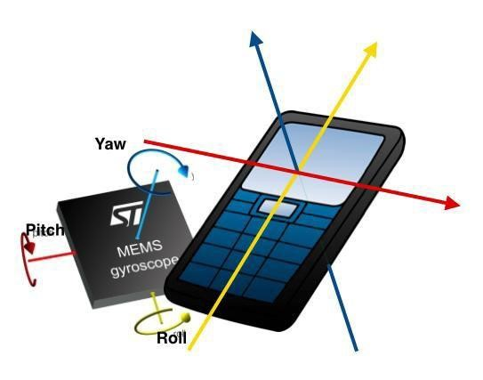Are needed to be trained and fine-tuned when the algorithm runs on different devices with various built-in sensors. However, labelling a training data (time-series data) is a time consuming procedure and it is not always possible to label all the training data by the users.

Understanding human activities creating a demand in health-care domain, especially in rehabilitation assistance, physiotherapist assistance, and elder care support services and cognitive impairment 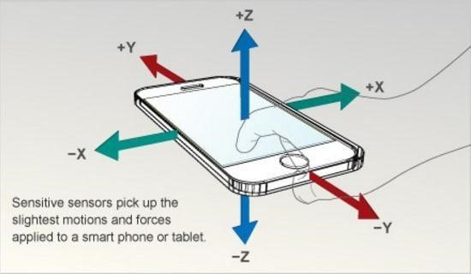

## Related Work

Human activity recognition on smartphone is an active research area. Most of related works focus on analysing the performance of classification algorithms such as: Decision Trees, Naïve Bayes, and Nearest Neighbour algorithms, Support Vector Machines, Hidden Markov Chain, Multi-Layer Perceptron and Random Forrest. There are not much work investigated on features selection of dataset. Jun Yang and et al. extracted orientation-independent features from three feature sets, including horizontal, vertical and magnitude features. Each feature set consists of mean, standard deviation, zero cross rate, 75 percentile, interquartile, spectrum centroid, entropy. The authors used Attributed Selection filters to give 7 feature subsets and evaluate recognition accuracy on these subsets. As a result, the accuracy of classifiers on each subsets are lower than with all features, i.e. Decision Tree equals to 90.4% (all features: 90.6%), Naïve Bayes equals to 68.3% (all features: 68.7%).

## FLOW CHART

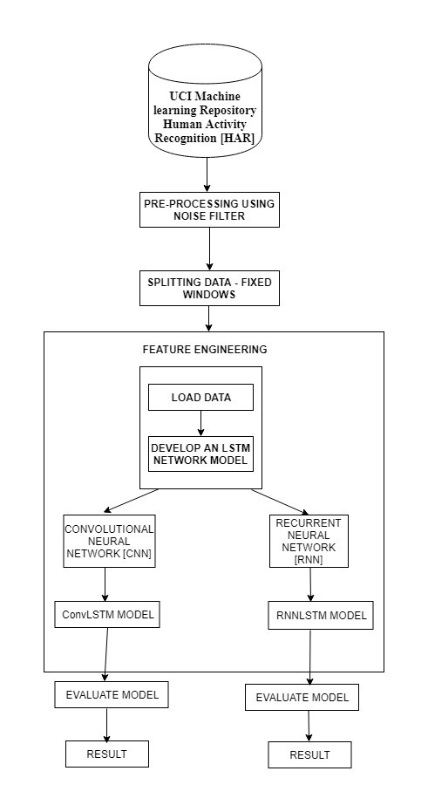

### Engineering Methodology/Implementation:

### Engineering Methodology:

This project is study based on the results obtained by training a neural network consisting of Convolutional layers, max pooling layers and dense layers separated by dropouts. The Python Libraries used in this project are as follows:

* Tensorflow
* Keras
* Numpy
* Matplotlib

All these libraries are either pre-installed on the VScode platform and if not can be manually download through “pip install package name” command on the python command prompt.

### Implementation:

Implementing this project has required the following few steps:

* Downloading Dataset
* Loading Dataset into VScode
* Splitting it into Training, Testing and Validation sets
* Augmenting the images for better accuracy (Only training set)
* Normalizing the dataset
* Creating the optimal neural network model
* Compiling the model
* Fitting the model to an object
* Changing the hyper parameters to improve accuracy
* Combining training and testing datasets and training the model with them

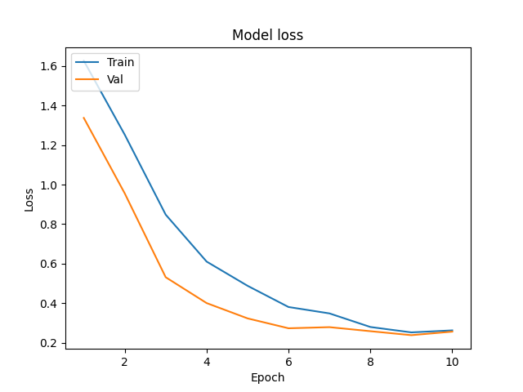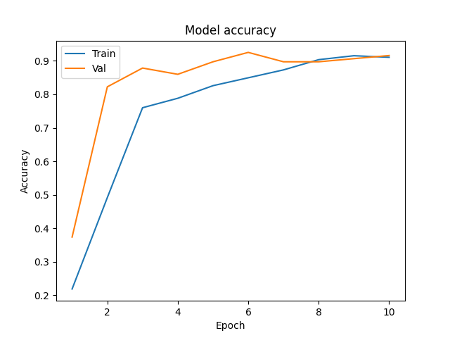

Conclusion

In this paper, we proposed an activity recognition system working on Android platforms by developing an application called application logger that supports on-line training and classification while using only the accelerometer data for classification

## References

1. [1] Xing Su, Hanghang Tong, and Ping Ji , ―Activity Recognition with Smartphone Sensors‖ ,tsinghua science and technology ISSN ll1007- 0214ll02/11llpp235-249 Volume 19, Number 3, June 2014.
2. [2] Nicholas D.Lane , Emiliano Miluzzo, Hong Lu, Daniel Peebles,‖A Survey of Mobile Phone Sensing‖,IEEE Communications Magazine September 2010
3. [3] Sahak Kaghyan, Hakob Sarukhanyan, ‖Activity recognition using knearest neighbor algorithm on smartphone with tri-axial accelerometer ‖,International Journal "Information Models and Analyses" Vol.1 / 2012J.
4. [4] Mustafa Kose, Ozlem Durmaz Incel,Cem Ersoy ‖Online Human Activity Recognition on Smart Phones‖2nd International Workshop on Mobile Sensing, April 16, 2012.
5. [5] Pekka Sirrtola and Juha Röning, ―Recognizing Human Activities Userindependently on Smartphones Based on Accelerometer Data‖,International Journal of Artificial Intelligence and Interactive Multimedia, Vol. 1, No 5.
6. [6] Jennifer R.Kwapisz Gary M. Weiss, Samuel A. Moore,‖Activity Recognition using Cell Phone Accelerometers‖,sensor KDD ‘10,july 25,2010 ,Washington,DC,USA.copyright 2010ACM.
7. [7] Ling bao and stephen S. Intille,‖Activity Recognition from User-Annotated Acceleration Data‖,. Ferscha and F.Mattern (Eds) PERVASIVE 2004, LNCS 3001, pp. 1–17, 2004. Springer-Verlag Berlin Heidelberg 2004.